

Operating system lab 2

Shiza Arshad

BSCS-5B

Reg # 127724



**Lab Task 1:** Write a shell script to display all the txt files on a directory then modify this script to display all the files on a directory?

**Code:**

echo "start"

echo "All text files"

ls *.txt

echo "All files:"

for entry in *

do

echo "$entry"

done

**Screenshot:**

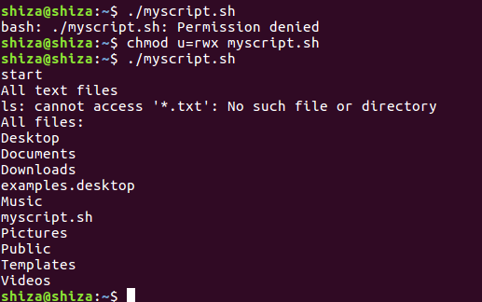

**Lab Task 2:**

Write a shell script to make a simple calculator which should be capable of performing basic calculations.

Also add a feature of repeated inputs from the user.

**Code:** sum=0

i="y"

while [ $i = "y" ]

echo " Enter first number"

read n1

echo "Enter second number"

read n2

do

echo "1.Addition"

echo "2.Subtraction"

echo "3.Multiplication"

echo "4.Division"

echo "Enter your choice"

read ch

case $ch in

1)sum=`expr $n1 + $n2`

echo "Sum ="$sum;;

2)sum=`expr $n1 - $n2`

echo "Sub = "$sum;;

3)sum=`expr $n1 \* $n2`

echo "Mul = "$sum;;

4)sum=`expr $n1 / $n2`

echo "Div = "$sum;;

*)echo "Invalid choice";;

esac

echo "Do u want to continue (y/n)?"

read i

if [ $i != "y" ]

then

exit

fi

done

**Screenshot:**

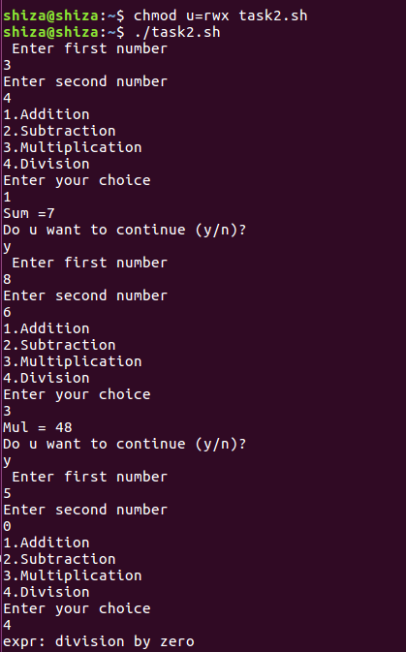

**Lab Task 3:**

Write a shell script to find out number of lines and number of words from a given file (you are not supposed to use wc command.

**Code:**

w=0

l=0

while read line

do

l=`expr $l + 1`

w=`expr $(IFS=' '; set -- $line; echo $#) + $w`

done < "text.txt"

echo "Number words: $w"

echo "Number lines: $l"

**Screenshot:**

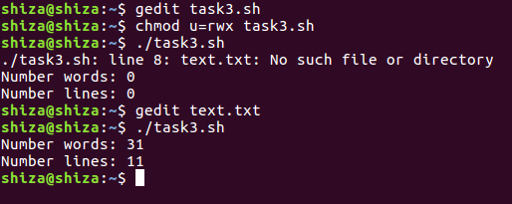

**Lab Task 4:**

Run the following script and check what it does:-

*************** file commands.sh******************

#!/bin/bash  
echo "hello world"

for f in *.txt; do  
    f2=${f%%.*}   
    echo filename $f2  
    cat $f | sed 's/(.*)//g' > ${f2}_modified.txt  
done

**********end of file commands.sh*************

Hint: text files contain strings like "aad(bbb)c c"

**Answer:** It reads the text file , removes everything in the parenthesis and saves it in a new file.